DEPLOY YOUR RAILS APPLICATION TO EC2 INSTANCE OF AMAZON

Step 1: Generate your rails project(Design one basic rails app to test on ec2-aws)

Step 2: Add Capistrono and puma gem to gemfile and bundle install

gem 'figaro'
gem 'puma'
group :development do
gem 'capistrano'
gem 'capistrano3-puma'
gem 'capistrano-rails', require: false
gem 'capistrano-bundler', require: false
gem 'capistrano-rvm'
end

Step 3: Generate Capistrono Configuration file

Command : cap install STAGES=production (if you want you can mention staging environment)
Output :
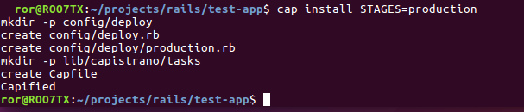
Step 4: Copy below to Capfile

require 'capistrano/rvm'
require 'capistrano/bundler'
require 'capistrano/rails/assets'
require 'capistrano/rails/migrations'
require 'capistrano/puma'

Step 5: Copy below to Deploy.rb in config folder

set :application, 'test-app'# Edit this to match your app name
set :repo_url, 'https://github.com/shiva-9731/sample-app-aws-ec2-deployment.git' # Edit this to match your repository
set :branch, :master
set :deploy_to, '/home/deploy/test-app'# Edit this to match your app-name
set :pty, true
set :linked_files, %w{config/database.yml config/application.yml}
set :linked_dirs, %w{bin log tmp/pids tmp/cache tmp/sockets vendor/bundle public/system public/uploads}
set :keep_releases, 5
set :rvm_type, :user
set :rvm_ruby_version, 'ruby-2.3.1' # Edit this if you are using MRI Ruby

set :puma_rackup, -> { File.join(current_path, 'config.ru') }
set :puma_state, "#{shared_path}/tmp/pids/puma.state"
set :puma_pid, "#{shared_path}/tmp/pids/puma.pid"
set :puma_bind, "unix://#{shared_path}/tmp/sockets/puma.sock" #accept array for multi-bind
set :puma_conf, "#{shared_path}/puma.rb"
set :puma_access_log, "#{shared_path}/log/puma_error.log"
set :puma_error_log, "#{shared_path}/log/puma_access.log"
set :puma_role, :app
set :puma_env, fetch(:rack_env, fetch(:rails_env, 'production'))
set :puma_threads, [0, 8]
set :puma_workers, 0
set :puma_worker_timeout, nil
set :puma_init_active_record, true
set :puma_preload_app, false

Step 6: Create New Ec2 Instance in AWS

Create new key pair file and downlod it while creating instace and generate ssh key of your system and copy it to new key pair file.

Step 7: Connect your Ec2 instance to your local system

ssh -i "sample-app.pem" ubuntu@ec2-35-162-190-216.us-west-2.compute.amazonaws.com
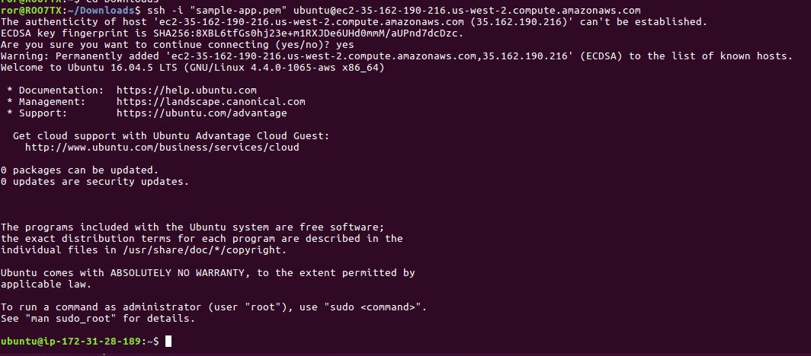
(NOTE: This will be available by selecting instance in your Ec2 dashboard and by clicking the connect button. Output will be as follows in the picture)

Step 8: Update and Upgrade your server

Command : sudo apt-get update && sudo apt-get -y upgrade

Step 9: Create new user and set password in ubuntu server

Command : sudo useradd -d /home/deploy -m deploy
sudo passwd deploy
Output :
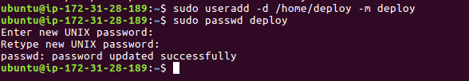
Step 10: Give sudo user password to deploy user

Command : sudo visudo

Enter the below text in the vi-editor save and exit

deploy ALL=(ALL:ALL) ALL

Step 11: Login as deploy user (User is the one we created in the step 9)

Step 12: Generate ssh key

Command : ssh-keygen

(By Default ssh key will be in the ssh file, no need entering any file name ,just press enter for all questions)

Output :
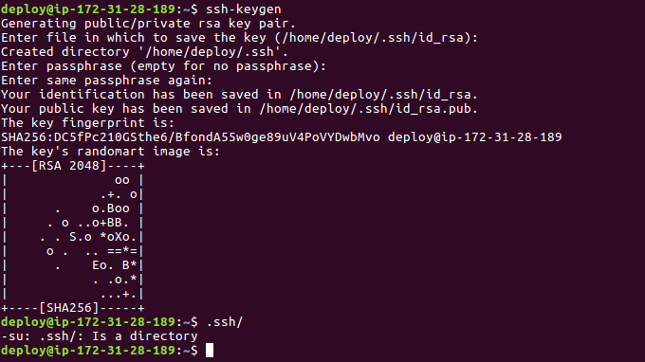
(Check ssh key directroy by using .ssh/ commnad)

Step 13: Move to ssh folder

Command :
cd .ssh/
ls

Step 14: Copy id_rsa.pub

Command :

cat id_rsa.pub

(Copy the key which came from the above command)

Output :
Step 15: Copy ssh key and add it your github repository

(Open repository in github and go to setting in profile bar, click on ssh and gpg key, add ssh key their)
Step 16: Check wether added ssh key is correct or not

Command :
ssh -T git@github.com

Output :
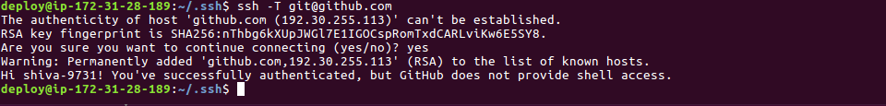
Step 17: Copy your local system ssh key in to server authorized key

Command :
cat ~/.ssh/id_rsa.pub

Output :

Command : (enter this command in server prompt)
vi authorized_keys
(paste this id_rsa..pub key into (vi editor) server authorized keys, save and exit)

Step 18: Install git in server

Command : (enter this command in sever prompt)
sudo apt-get install git

Output :
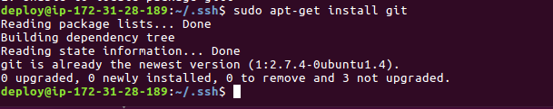
Step 19: Install nginx server in server

Command : (enter this command in sever prompt)
sudo apt-get install nginx

Step 20: Edit nginx server file

Command : (enter this command in sever prompt)
sudo vi /etc/nginx/sites-available/default

(Comment all the line in the vi editor , which you got from the above command)
(Paste the below code in vi editor)

upstream app {
# Path to Puma SOCK file, as defined previously
server unix:/home/deploy/urlshortner/shared/tmp/sockets/puma.sock fail_timeout=0;
} #Change the urlshortner to your app-name

server {
listen 80;
server_name localhost;

root /home/deploy/urlshortner/current/public; #Change the urlshortner to your app-name

try_files $uri/index.html $uri @app;

location / {
proxy_set_header X-Forwarded-Proto $scheme;
proxy_set_header X-Forwarded-For $proxy_add_x_forwarded_for;
proxy_set_header X-Real-IP $remote_addr;
proxy_set_header Host $host;
proxy_redirect off;
proxy_http_version 1.1;
proxy_set_header Connection '';
proxy_pass http://app;
}

location ~ ^/(assets|fonts|system)/|favicon.ico|robots.txt {
gzip_static on;
expires max;
add_header Cache-Control public;
}

error_page 500 502 503 504 /500.html;
client_max_body_size 4G;
keepalive_timeout 10;
}

(NOTE: Save and exit)

Step 21: Go to github repository, copy the ssh url of repository

and

change

it in your local system app deploy.rb file

(NOTE: change : repo_url to the github ssh url)

Step 22: Install postgresql in your server

Command :
sudo apt-get install postgresql postgres-contrib libpq-dev

Step 23: Create user in postgres

Command :
sudo -u postgres createuser -s user_name

Step 24: Create password for postgress user

Command :
sudo -u postgres psql

postgres=# \password user_name

Enter new password:
Enter it again:
postgres=# \q (quit or come out of psql)

Step 25: Create Database

Command :
sudo -u postgres createdb -O user_name app_name_production

(NOTE: database name should be name of app followed by production)

Step 26: Install RVM for installing ruby

Command :
su – deploy ( Login as server user , the one which you created)

gpg --keyserver hkp://keys.gnupg.net –recv-keys 409B6B1796C275462A1703113804BB82D39DC0E3

\curl -sSL https://get.rvm.io | bash -s stable

Step 27: Install ruby using RVM

Command :
rvm insall ruby_version

(NOTE: Ruby version of your app)

Step 28: Install bundler gem

Command :
gem install bundler --no-ri –no-rdoc

Step 29: Create a new folder

Command :
mkdir folder_name

Step 30: Create another two folder
--> shared
--> config (inside shared)
Command :
mkdir -p folder_name/shared/config

(NOTE : folder name is the name which you have created before)

(Then check folders wether created or not by using ls command)

Step 31: Go to shared folder

Step 32: Create one more file called database.yml

Command :
nano config/database.yml
(as soon as you enter this command , it will take you to vi editor, their you need to paste the below setup data and make necessory changes)

production:
adapter: postgresql
encoding: unicode
database: urlshortner_production #production database name
username: urlshortner #user name of production psql database
password: urlshortner #password of production psql database
host: localhost
port: 5432 (NOTE : save in database.yml file and exit)

Step 33: Create one more file called application.yml

Command :
nano config/applicaton.yml
(as soon as you enter this command , it will take you to vi editor, their you need to paste the below setup data and make necessory changes)

SECRET_KEY_BASE: "8a2ff74119cb2b8f14a85dd6e213fa24d8540fc34dcaa7ef8a35c246ae452bfa8702767d19086461ac911e1435481c22663fbd65c97f21f6a91b3fce7687ce63"

Step 34: Add configuration in production.rb (in the last line)

server '52.32.208.85', user: 'deploy', roles: %w{web app db}

( NOTE: deploy is server user name so change it to your server username, and change the ip address to user ec2 instance ip adderss)

Step 35: You have done all configuration setup.

It is time to deploy your app.

Step 36: Start deploying your applicaion to server

Command :
cap production deploy
(NOTE: Command should be executed in your local machine prompt not in production prompt)

Step 37: Start nginx server in your server prompt

Command:
sudo service nginx start

Step 38: Copy your ec2 instance ip address from ec2 dashboard , run and check

THANK YOU

(NOTE : Check the below github link for all configuration files, if you need?)

https://github.com/shiva-9731/rails-ec2-configuration.git

(NOTE : Check the below youtube link for video, if you need?)

https://www.youtube.com/watch?v=imdrYD4ooIk&t=2s
(This video teachs how to deploy rails app to ec2 aws server with using capistrono gem and nginx server)

https://www.youtube.com/watch?v=jFBbcleSPoY
(This video teachs how to deploy a small html pages and small rails app to ec2 aws server without using capistrono gem and nginx server)

